**Convex and concave**

Convex is perfect in minimization problems as there is unique minimum “Local min = Global min”.

Concave is perfect in maximization problems as there is unique minimum “Local max = Global max”.

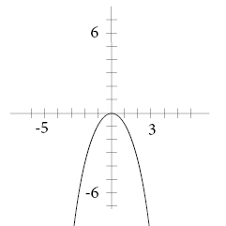

Non-convex and non-concave is not easy for optimization problem as it may has more than one local min and local max.

